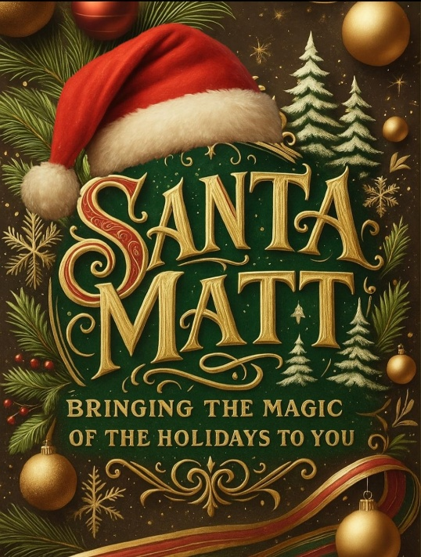

**Preparing to Visit Santa: Tips for a Magical Experience**

Visiting Santa is one of the most cherished traditions of the holiday season — a moment filled with excitement, wonder, and a little bit of Christmas magic. To help make your visit as joyful and stress-free as possible, here are a few helpful tips from Santa himself!

✨ **Make It a Fun Family Activity**

A visit to Santa should be a joyful outing for everyone. Dress children in comfortable clothes they enjoy wearing — when kids feel good, it shines through in the photos! A relaxed and happy family creates the best memories (and the best smiles).

📖 **Talk About Santa Before Your Visit**

Before heading out, spend some time talking with your children about who Santa is and what he represents — love, kindness, and the spirit of giving. Reading a Christmas story together or watching a holiday movie helps children feel familiar and excited to meet the jolly old elf in person.

🎀 **Be Photo-Ready**

A few last-minute touch-ups can make a big difference! Bring a comb or brush, moist towelettes, and any needed hair ties or bows for those final adjustments. Wipe sticky hands and faces before your turn — Santa appreciates keeping his beard and suit clean and snowy white!

📸 **Capture the Perfect Photo**

The best photos are often taken within the first 15 seconds! Help your children get into position, then step back and let the magic happen. After the photos, Santa will take time to talk with the children — giving everyone a warm, relaxed experience.

👶 **For Babies (Newborn to 6 Months)**

For our tiniest visitors, timing is key! Once Santa is holding your baby, photographers usually have just a few seconds to capture that perfect shot. Have everyone else in position before gently placing your little one in Santa’s arms.

💕 **For Shy or Scared Children**

It’s normal for some children to feel nervous around Santa. Avoid saying phrases like “Don’t be afraid” or “Santa won’t hurt you,” as they can unintentionally increase anxiety. Instead, let your child watch others visit Santa to build comfort. If they’re still hesitant, they can sit in Santa’s chair while he stands nearby — or even back gently into his lap. Remember, no child should ever be forced to visit Santa. The goal is to create happy memories, not stressful ones.

👶 **Change Diapers Before Visiting**

If you have little ones, please make sure all diapers are clean before meeting Santa. A soiled suit stops the whole operation until it can be cleaned — and we wouldn’t want to delay the Christmas magic for anyone! If you need to step out of line for a quick change, simply let an elf helper know — they’ll gladly save your place.

🤒 **Keep Sick Children at Home**

Santa meets many families throughout the season, so it’s important to keep everyone healthy. If your child (or anyone in your family) is sick, please stay home and visit once everyone is feeling better. Santa wants to keep the Christmas spirit — and his beard — germ-free!

🎄 **Final Thoughts from Santa**

A visit with Santa should always be filled with laughter, warmth, and joy. A little preparation goes a long way toward making the experience magical for both children and parents alike.

Santa can’t wait to see you soon — and remember, it’s not just about the photos… it’s about the memories that will last a lifetime.