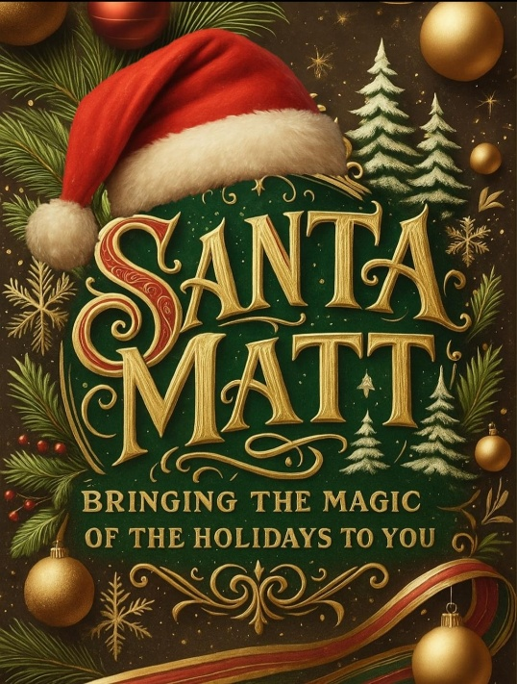

**Preparing to Visit Santa**

**Make it a fun activity.**

When you visit Santa you want to make it a joyful outing. Make sure children are in comfortable clothes that they want to wear. This will put everyone in a good mood and be reflected in the pictures.

**Talk to your children before visiting Santa.**

Before going to visit Santa, talk with your children about Santa and what he represents. Read stories or watch movies with Santa so your children can see that he is a symbol of love and giving.

**Before leaving make sure you are prepared for the photos.**

Bring a comb or brush along with moist towelettes and any other hair ties or bows you need for last minute touch ups. Any sticky fingers and hands should be wiped before visiting Santa to keep his beard and suit clean.

**Prepare for the photos.**

The best photos are taken within the first 15 seconds so help your children into position for photos with Santa then retreat back. After photos, Santa can talk with the children.

**Newborns to 6 months of age.**

Bring your baby to Santa and place them in his arms. With children this young you often have about 5 seconds to take pictures once Santa is holding them, so have everyone else in position before placing them in Santa’s arms.

**Scared children**

Before a visit or while standing in line to see Santa try not to say things like “Don’t be afraid” or “Santa won’t hurt you”. This often has the opposite effect and can make children more fearful. You wouldn’t say this about other characters or mascots, so why Santa? Allow children to watch other children with Santa to calm their nerves. If still nervous, small children can be backed into Santa or they can be allowed to sit in Santa’s chair while he stands behind it.

Never force a child to visit Santa, this can be traumatic!

**Children with wet bottoms**

Please change all soiled diapers before children visit Santa. It Santa’s suit gets soiled it will stop the whole operation until he can clean up. If you need to leave the line to change your children, tell a helper or Santa and they can bring you to the front of the line when you return.

**Sick children**

Please have any sick children or family members stay at home. Santa visits so many children this season and he wants to keep all children, his family, and himself free of any illnesses.